Technical Specification

This is the technical source of truth for the delivered build. Update it in the same
milestone as any architectural, interface, data, configuration, or deployment change.

System purpose and scope

- Purpose: A personal, hosted, self-refreshing dashboard of US public-health surveillance data sourced from PopHIVE.
- In scope: See 01-scope.md.
- Out of scope: See 01-scope.md.

Architecture overview

Static site (Next.js 16, App Router — D-006) built locally today, targeting Vercel
hosting (M7, not yet deployed). A build-time data pipeline (web/scripts/build-data.ts,
run via npm run build:data, wired as the prebuild script) uses DuckDB (D-007) to
query PopHIVE parquet bundles directly from raw.githubusercontent.com/PopHIVE/Ingest
over HTTP, plus NYC DOHMH's own CSV data (D-008) for true per-borough figures, applies
data-quality transforms in SQL/TypeScript, and writes static JSON to
web/data/generated/ (gitignored, regenerated every build). Server Components import
that JSON directly at build time; all interactivity (disease/signal selection,
drill-down, tab switching) happens client-side against the data already embedded in the
page — there is no runtime API or database.

Build-time data flow

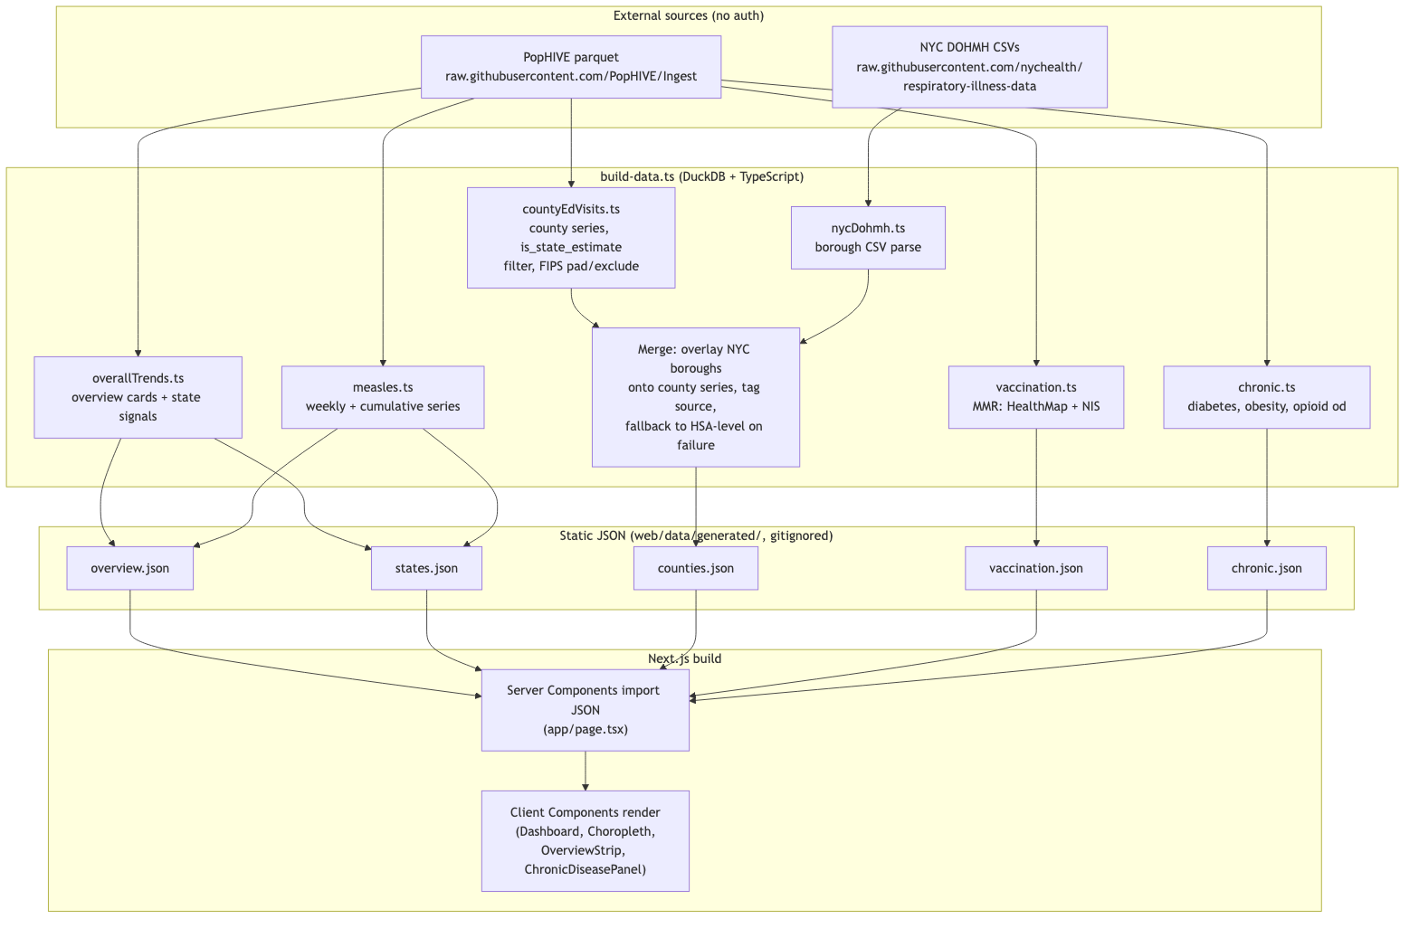

Deployment / refresh loop (target, M7 — not yet built)

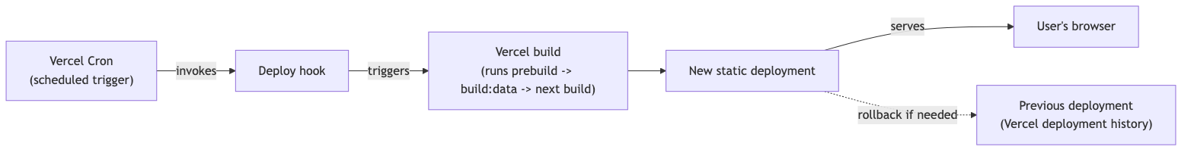

NYC borough blend (D-008)

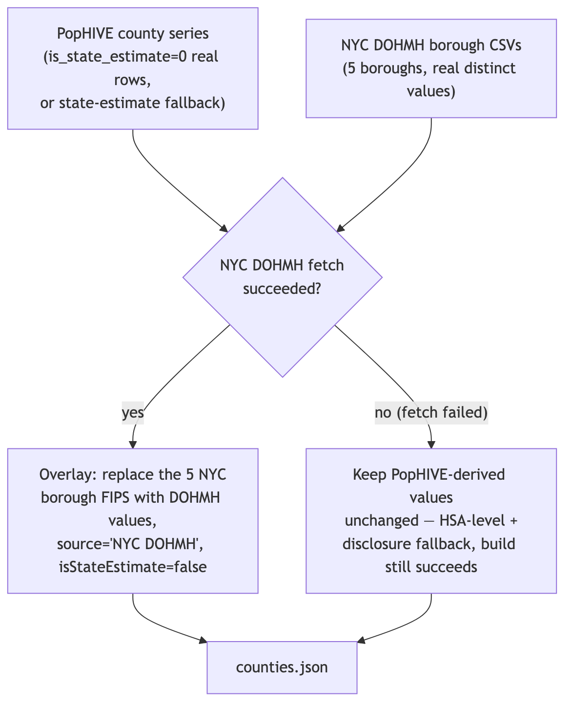

Rendered from the Mermaid source above; regenerate the diagram images if this section
changes (see the Word-export note in this document's governance, if applicable).

Components

Folder structure

Public Health Tracker/ # git repo root
Project Documents/ # PM/product docs (this file's folder)
web/ # Next.js application root
app/
page.tsx # Server Component: imports JSON, renders Dashboard
layout.tsx
globals.css # Design tokens (see 12-visual-style-guide.md)
components/
Dashboard.tsx # Top-level client component, all interactive state
Choropleth.tsx # Map rendering, tooltip, legend
OverviewStrip.tsx # 4 status cards
ChronicDiseasePanel.tsx # Chronic-disease tab
lib/
pophive/
duckdb.ts # DuckDB query helper
fips.ts # FIPS padding/exclusion helpers
states.ts # US state FIPS/name/abbr crosswalk
types.ts # Shared data types
bands.ts # Our own level/trend heuristics (documented as approximate)
overallTrends.ts # flu/covid/rsv overview + state series
measles.ts # measles weekly/cumulative series
countyEdVisits.ts # county-level ED-visit series
vaccination.ts # MMR coverage (HealthMap + NIS)
chronic.ts # diabetes/obesity/opioid-overdose
nycDohmh.ts # NYC borough CSV fetch/parse
topology.ts # us-atlas TopoJSON -> GeoJSON helpers
scripts/
build-data.ts # Orchestrates the full pipeline, writes JSON
inspect-bundle.mjs # Dev tool: print schema/sample rows for any PopHIVE file
data/generated/ # Output JSON (gitignored, regenerated every build)

Code organization

APIs and integrations

Confirmed NYC DOHMH schema (M3 spike, 2026-07-26)

Verified via direct fetch of the raw CSVs (not assumed from the repo's README):

- ED_data_influenza.csv, ED_data_COVID-19.csv, ED_data_RSV.csv — each: date, {Disease} visits overall, visits 0-4, visits 5-17, visits 18-64, visits 65+, visits Bronx, visits Brooklyn, visits Queens, visits Manhattan, visits Staten Island, {Disease} hospitalizations overall, ...(same age/borough breakdown).
- Confirmed borough values are genuinely distinct per row (not a shared/duplicated value), unlike PopHIVE's NSSP HSA-level rows.
- Confirmed continuously updated through the same week as PopHIVE at check time (2026-07-18) — not gapped outside the Oct-May flu/RSV season as the repo's human- readable weekly bulletins might suggest; that description applies to the PDF bulletins, not this CSV feed.
- No measles file exists in this repo — measles has no per-borough source at all (PopHIVE's own measles data is state-level only), disclosed as such in the UI rather than silently omitted.

Data model and storage

No PII/PHI: PopHIVE data is public, aggregate, and de-identified per its own governance
(see MCP server instructions).

Configuration

Never record actual secret values.

Dependencies

Security and privacy

- Trust boundaries: Build-time fetches from two public, unauthenticated sources (PopHIVE parquet, optionally NYC DOHMH open data). No user-submitted data, no auth layer (personal, unlisted deployment).
- Authentication and authorization: None — single user, unlisted URL.
- Sensitive data handling: None — all source data is public/aggregate/de-identified.
- Validation and sanitization: Data-quality rules (suppression, FIPS exclusion, cadence separation) are the primary "validation" concern here, applied for correctness rather than security.
- Logging and audit: Not required for a personal single-user static site.
- Known risks: A failed or partial build could ship stale data; mitigated by failing the build loudly (see APIs and integrations) and always showing real as_of dates.

Error handling and observability

- Error strategy: Build-time failures (fetch/parse errors, missing expected columns) fail the build rather than shipping partial data.
- Logging: Standard Vercel build logs.
- Metrics: None planned for v1 (personal project, no dashboard-of-the-dashboard).
- Alerts: None planned for v1; staleness is self-evident via the as_of date.
- Health checks: None planned for v1.

Build, test, and deployment

- Local setup: cd web && npm install, then npm run build:data to generate JSON, then npm run dev (Next.js/Turbopack dev server).
- Build: npm run build runs prebuild (= build:data) automatically, then next build.
- Automated tests: None yet — see 05-tests.md.
- Manual verification: Pipeline console output cross-checked against PopHIVE's own get_current_status calls and the brief's section 7 reference figures (exact matches confirmed for flu/RSV/COVID national status and HealthMap MMR coverage); full interactive browser verification completed 2026-07-26 (Chrome, desktop + 420px viewport) — see 08-project-plan.md milestone completion notes for what was checked.
- Deployment: Not yet done (M7) — target is Vercel, connected to this git repo, with a scheduled rebuild via Vercel Cron + deploy hook. Requires confirming the user's Vercel/GitHub account setup before creating any hosted/shared resources.
- Rollback: Once deployed, Vercel's deployment history allows instant rollback to any prior build. Locally, git history serves the same purpose.

Performance, reliability, and accessibility

- Expected load: Single user, low request volume — no scaling concerns.
- Performance requirements: None strict; static generation keeps page loads fast by default. Known cost: counties.json is ~1.2MB (all 3 respiratory diseases' county data shipped to the client at once) — acceptable for a personal tool, tracked as E-007 (lazy-load per state) if it ever feels slow.
- Availability or recovery expectations: Personal project — best-effort; Vercel's platform reliability is sufficient once deployed.
- Accessibility requirements: Standard practice per the visual style guide (contrast, keyboard nav, focus visibility) — see 12-visual-style-guide.md. Known gap: map state-click drill-down has no keyboard equivalent yet (E-010).

Technical limitations and debt

Confirmed real bundle files (M1 schema discovery, 2026-07-25)

Verified via DuckDB DESCRIBE/SELECT against the live GitHub-hosted parquet files
(not assumed from the brief's docs site, which may lag):

- bundle_respiratory/dist/flu_ed_visits_by_county.parquet — source, fips (DOUBLE), week_end (DATE), percent_visits_flu (DOUBLE), is_state_estimate (DOUBLE)
- bundle_respiratory/dist/covid_ed_visits_by_county.parquet — same shape, percent_visits_covid
- bundle_respiratory/dist/rsv_ed_visits_by_county.parquet — same shape, percent_visits_rsv
- bundle_measles/dist/measles_county.parquet — geography (VARCHAR), is_state_estimate (DOUBLE), date (DATE), year (INTEGER), week (INTEGER), source (VARCHAR), value (DOUBLE)
- bundle_measles/dist/measles_state.parquet — geography (VARCHAR, state name), date (DATE), year (DOUBLE), week (DOUBLE), source (VARCHAR), value (DOUBLE)

Full file listing for bundle_respiratory, bundle_measles,
bundle_childhood_immunizations, and bundle_chronic_diseases was retrieved from the
GitHub contents API (api.github.com/repos/PopHIVE/Ingest/contents/data/<bundle>/dist)
to avoid guessing filenames; measles has no ED-visits-style file (it's tracked via case
counts, not NSSP visit %, which matches the brief's description). Childhood-immunization
and chronic-disease file schemas are not yet inspected — planned before M5/M6.

Additional data-quality catches (M5/M6)

- bundle_childhood_immunizations/dist/wapo_vax_counties.parquet's wapo_county_vax_rate didn't reconcile with its sibling file's per-school exemption-rate columns (e.g. a school with a 1% "overall rate" and 0% exemptions across all categories) — deferred rather than ship a possibly-mislabeled county vaccination metric (E-011).
- bundle_chronic_diseases/dist/overdose_by_geography_and_source.parquet's value column produced implausible state overdose-death rates (~120-140 per 100k at the most recent date checked, against a real-world ceiling around 40-55) — used overdose_deaths_state.parquet instead, whose numbers passed a sanity check against known CDC ranges.

Specification change log

